BLOGPOST - From Launch to Series A: Get Your Finance Plan Right

From Launch to Series A: Get Your Finance Plan Right
10 Prios Before You Reach 10k MRR — SaaS SMBs Ed.
About this series
This series of articles are drafted from our experience at Point Nine Capital on the top priorities for early-stage SaaS companies.
Note that though more relevant for startups who focus in SMBs first and then go upmarket, the priorities are general enough to apply to most SaaS companies.
If you want to be kept informed of our new posts you can subscribe to our content newsletter or follow our Medium channel.
Priority 3: Get Your Finance Plan Right
It always takes longer … plan accordingly



Great video here: The Long, Slow, SaaS Ramp of Death
Unfortunately, it will almost always take longer than you think to get to the +100k MRR required for the series A.
Our limited sample tells us that it tends to take 12 months to get to 10k and another 12 to go from 10k to 100k. Some exceptional founders in great markets can do it in less time.
But if you’re early on, better to be slightly conservative. Ideally, you should try to budget a plan for at least 24 months to get there, but at least plan for 18 months.
It’s also important that you understand and take into account when you might be ready to raise funds. Raising extra money when you’re between seed and series A tends to be tricky. Furthermore, it can be highly dilutive with the wrong investors onboard.
Be reasonable with your plan … there is a lot at risk
Those previous aspects are the focus of the last post, Priority #10: Get Enough Funding. But a good financial plan is a must to help you monitor and understand your progress — and avoid running out of cash!
The nice thing about SaaS is that the key metrics are easy to track and benchmark, but don’t over-engineer it. Here you have a great template for a financial plan for a SaaS startup. A good template is already a good start, but obviously, what matters is the hypotheses on it ;-)

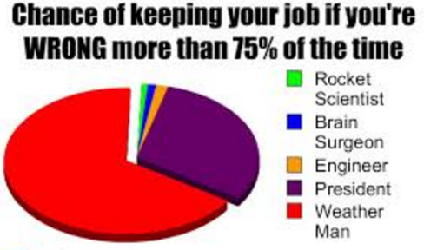

Unless you’re the weather man or the president, better to get the forecast right…
For the first few months of revenue, it’s almost impossible to forecast anything with accuracy. In any case, adding more than a few thousand new MRR monthly is a stretchy guess. Past 30–50k MRR you start to have some data towards understanding your growth, at which point +10–20% monthly growth becomes challenging.
Please, don’t fool yourselves with unrealistic unit economics, here some rough benchmarks —note that unit economics are very dependant on your market, so don’t take them as “the Truth” either!

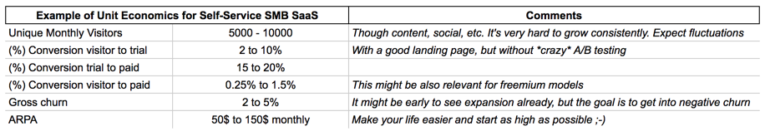
Then, when it’s about spending money, you should focus your limited resources on what matters most: your first hires. A good benchmark is to spend +70–80% of your burn on salaries.
Obviously those great hires tend to have high salaries in their current jobs. Here is where equity can compensate for the lower salary you will need to offer. But don’t be too cheap — there’s a limit on what people are willing to cut their salary to move into a startup.
A word of caution about building an “intern’s company”. The money you can save in salaries means slower progress and more burden to manage and teach them. That, at the end, can result in more burn over time.



Please, wait for the Series A/B funds for that… You know, micro VCs have small funds ;-)
But in any case, try to avoid any extra burn. Every penny might be critical when you run out of money. Specially, wait for the big series A/B for the fancy offices, expensive trips, big marketing budgets, salary increases, etc.
“Wasting” pocket money into marketing could make sense to experiment with different acquisition channels. But make sure it’s about testing, rather than trying to grow your company through paid at this stage. More on that in a following post (Priority #5: Invest in Sales and marketing).

Aus <https://medium.com/point-nine-news/from-launch-to-series-a-get-your-finance-plan-right-3-10-ba4927e274f8#.a0wq7z7p9>

